# School of Engineering and Technology, University of Washington, Tacoma TCSS 305 Programming Practicum Assignment 5

# Value: 4% of the course grade

### Program Description:

This assignment is designed to test your understanding of graphical user interface components in Java using Swing. You will write the graphical user interface (GUI) for an application that displays and manipulates images; the image processing classes have been provided for you.

When the program initially loads, it should have the following appearance. The window title should be “TCSS 305 - Image Filter Program”. The window should be sized to exactly fit the buttons and should appear centered on the screen. The ‘W’ icon shown in the upper left corner of the JFrame is from a file supplied with the starter code. You can learn how to display the icon on the JFrame by studying the assignment 3 code from earlier this quarter. Note that on Mac computers the icon may not appear on the JFrame, but will appear when the application is minimized.

There are equal sized buttons along the left edge of the window labeled "Edge Highlight", "Flip Horizontal", "Flip Vertical", "Grayscale", "Sharpen", and "Soften". There are normal sized buttons centered along the bottom labeled "Open..." and "Save As..." (each with 3 dots called an ellipses) and a button labeled "Close Image". Note that the buttons at the bottom display icons which are provided with the project starter code. Note that the buttons on the left are initially disabled and so are the "Save As..." and "Close Image" buttons. (The only button initially enabled is the "Open..." button.) When the user clicks "Open..." a JFileChooser Open dialog appears to let the user select a file. The JFileChooser dialog should appear centered on top of the program’s main window. Have the file selection dialog initially open in the project’s root directory (the current directory) as shown below (use relative addressing).

When the user selects a file, the system loads image data from that file and displays that image in the center of the window (as shown on the next page). The window resizes to exactly fit the image and buttons; if the image is too large, this may make some of the buttons appear outside the screen area (this is expected behavior, and you do not need to handle it in any special way). If the user later presses the "Open..." or "Save As..." button again, the FileChooser should open the same folder where the file chooser was used previously. If the user cancels the file chooser, the contents of the window are left unchanged.

When an image is loaded, all buttons become enabled (as shown below). Clicking each filter button causes a modification of the image: flipping, sharpening, softening, *etc*. Applying more than one filter to an image has a cumulative effect. These operations do not modify the original image file, they just change the onscreen appearance. If the user chooses a file that does not contain valid image data, the program displays the error message dialog (exactly as shown below). The error dialog should appear centered on top of the program’s main window. If the user chooses "Close Image", the image should close, all buttons should disable except the "Open..." button, and the GUI should resize to its initial size and appearance. If the "Open..." button is used while an image is already open, a new image may be selected to replace the current image. Only one image can be open and displayed for editing at a time. When the GUI window is closed, the program should exit.

If the user chooses to resize the GUI, the buttons on the left should adjust height so that they each remain equal in height and each button should use 1/6 of the available height. The buttons should all have the same width and that width should not change when the GUI is resized. The image should remain centered horizontally and vertically as the GUI is resized as shown below.

NOTE: Keep in mind that various operating systems have small differences in the way they display a GUI. When you run the program on your machine it may not look *exactly* like these screen shots; however, the behavior should be as described here.

After using filter button(s) the updated image can be saved by clicking on the “Save As…” button. This will cause a JFileChooser Save dialog to appear centered on the program’s main window. The JFileChooser Save dialog should open in the directory previously used byt the JFileChooser.

**Implementation Guidelines:**

You will write a class named GUI in the gui package that contains the implementation of your graphical user interface. You may also write additional helper classes, if you find it necessary. Your class may extend JFrame, but this is not required (if you do not extend JFrame, you will have to store a JFrame as an instance field). Do one or the other, but not both. Your JFrame must be resizable. As the JFrame is resized, any loaded image should remain centered both horizontally and vertically.

The constructor to your class must require no parameters, and must not display the GUI on the screen; instead,

your class must contain a method named start() that performs all necessary work to create and show the GUI

on the screen. Note that this does not mean that all the work should be performed in the start() method itself;

the start() method could call other methods to create various parts of the user interface (buttons, panels), set

up event handlers, etc. Note that the main method in the Driver class calls the GUI constructor and then calls start().

You do not need to write your own code to apply the different transformation filters to the pixels in the image. Do this by using the instructor-provided filter classes. Note that a single filter object can (and should) be used multiple times; you *must not* create more than one of each type of filter object.

The following class diagram gives a summary of the classes in the project and their relationships. The GUI is constructed by the Driver class. The GUI uses Filters to filter PixelImages that are composed of Pixels.

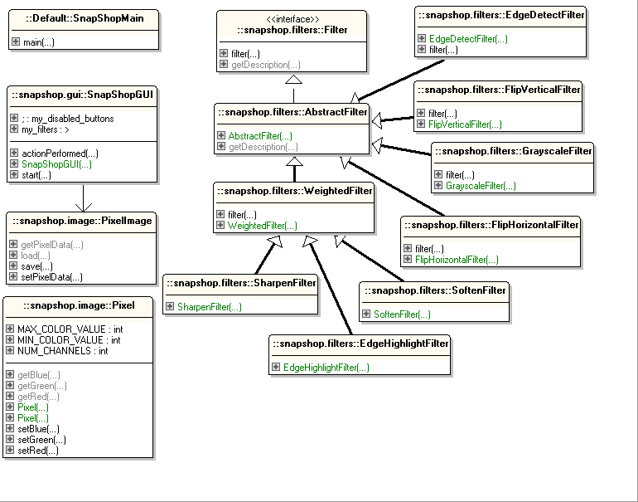

**SoftenFilter**

**SharpenFilter**



**EdgeHighlightFilter**

**FlipVerticalFilter**

**WeightedFilter**

**FlipHorizontalFilter**

**GrayScaleFilter**

**AbstractFilter**

**Pixel**

**Filter**

**PixelImage**

**GUI**

**Driver**

uses

This is the class you will write.

starts

### Provided Files:

The following classes and interfaces are provided for your use. You ***must not*** modify these files when writing your program. The classes have other methods beyond what is listed, but the listed methods are all you need.

Interface Filter:

|  |
| --- |
| public interface Filter {  // Applies this filter to the given image.  public void filter(PixelImage theImage);  // Returns a text description of this filter, such as "Edge Highlight".  public String getDescription();  } |

The following classes implement the Filter interface. Each has a no-argument constructor.

|  |
| --- |
| public class EdgeHighlightFilter implements Filter  public class FlipHorizontalFilter implements Filter  public class FlipVerticalFilter implements Filter  public class GrayscaleFilter implements Filter  public class SharpenFilter implements Filter  public class SoftenFilter implements Filter |

Class Pixel:

|  |
| --- |
| public class Pixel {  public Pixel() // constructs a black pixel  public Pixel(int theRed, int theGreen, int theBlue) // RGB values, 0-255  public int getRed(), getGreen(), getBlue()  public void setRed(int theRed), setGreen(int theGreen), setBlue(int theBlue)  } |

Class PixelImage:

|  |
| --- |
| public class PixelImage {  // Loads an image from the given file and returns it.  // Throws an exception if the file cannot be read.  public static PixelImage load(File theFile) throws IOException  // Saves this image to the given file.   // Throws an exception if the file cannot be written.  public void save(File theFile) throws IOException  // Methods to get and set the 2D grid of pixels that comprise this image.  // The first dimension is the rows (y), the second is the columns (x).  public Pixel[][] getPixelData()  public void setPixelData(Pixel[][] theData)  } |

Class Driver:

|  |
| --- |
| public class Driver {  // Runs your program by constructing a GUI object.  // (You must write the GUI class.)  public static void main(String... theArgs)  } |

### Extra Credit:

For 5 points (that’s 5% of the assignment’s value) extra credit, you may choose to implement code to warn a user from accidentally over writing an existing image file when the user chooses to save changes. Your extra credit should warn the user if they are about to overwrite a file and ask for a confirmation before doing so. The user should be able to choose to overwrite the existing file or to cancel the save command.

(Your implementation should not prevent a user from overwriting a file if that is the user’s intention.)

NO EXTRA CREDIT will be awarded for this if the normal Save As… functionality is not correct.

### Hints:

Display an image on the GUI by setting it to be the icon of an onscreen JLabel. A JLabel's icon is set by calling its setIcon method. The setIcon method accepts an ImageIcon object as a parameter. An ImageIcon object can be constructed by passing a PixelImage as the parameter. Here is an example that creates a new label and sets its icon (note that you should not create a new label every time you change the image, but instead should change the icon of the label you already have).

PixelImage image = PixelImage.load(new File("apple.jpg"));

JLabel label = new JLabel();

label.setIcon(new ImageIcon(image));

Use a JFileChooser for your file selection dialog. A save dialog can be shown by calling showSaveDialog on a JFileChooser object, and an open dialog can be shown by calling showOpenDialog. You can ask for the file the user selected by calling the getSelectedFile method on the JFileChooser. If image loading fails, catch the IOException and use a JOptionPane to display an error message dialog like the one shown on the page 2 of these instructions. Your program should create only one JFileChooser object and reuse it.

When an image is selected and loaded, call the pack method on your JFrame to make it resize itself to fit the

image and buttons. If the image is too large, pack may make your window larger than the screen; that’s OK

(I won’t test the program with images that are too large).

Try to design and implement an efficient way of creating filter objects and their corresponding buttons. Ideally, it should take you *exactly* one line of code to create each filter and its corresponding button and the button's ActionListener (6 such lines of code). The goal is to make it possible to easily add (or remove) a filter and its corresponding button without making changes to other parts of the project code.

Included with the project are some image files you can use for testing and some icon files to add to the buttons at the bottom of the GUI and to the JFrame.

# Submission and Grading:

Create your Eclipse project by downloading the assignment5-project.zip file from the Assignment 5 page on Canvas, importing it into your workspace (as described in Assignment 1), and using “Refactor” to change “username” in the project name to your UWNetID. Submit your completed Eclipse project file (.zip) and your executive summary (.txt) on Canvas as was done in previous assignments.

The filename for your executive summary must be “username-assignment5.txt”, where username is your UWNetID. An executive summary template is available on the Canvas. Executive summaries will *only* be accepted in plain text format – other file formats (RTF, Microsoft Word, Acrobat PDF, Apple Pages) are *not* acceptable. You will, in general, not lose any points on your executive summary itself unless you fail to turn it in or it is short of the length requirement and / or trivial.

Part of your program's score will come from its "external correctness." For this assignment, external correctness

is graded by running the GUI and examining the result. Exceptions should not occur under normal usage. The program should not produce any console output.

Another part of your program's score will come from its "internal correctness." Internal correctness includes meaningful and systematically assigned identifier names, proper encapsulation, the use of comments on particularly complex code sections, Javadoc, and the inclusion of file header comments. On this assignment avoidance of redundancy is important because it is easy for GUI code to become redundant especially when there are many similar elements (such as the filter buttons). In particular, avoid redundancy in file choosers (don’t create more than one file chooser object) and filters and their buttons (create only one instance of each filter type, don’t duplicate the same code multiple times with only minor textual differences to create each filter button). Try to find the most concise and elegant way possible to create the GUI without repeating nearly identical code many times. Internal correctness also includes whether your source code follows the stylistic guidelines discussed in class. This includes criteria such as the presence of Javadoc comments on *every* class, method, and field, the use of variable names, spacing, indentation, and bracket placement specified in the class coding standard, and the absence of certain common coding that can be detected by the tools. It is therefore to your advantage to be sure the plugin tools like your code before you submit it.

For this assignment, the percentage breakdown is 10% executive summary, 55% external correctness, 35% internal correctness.